Name: _________________________ Date: __________________

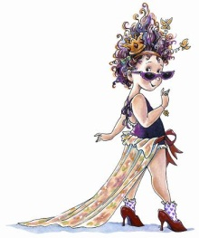 **Fancy** Word

What words can you make using the letters in the **fancy** word?

Write a sentence using the **fancy** word.